CSC111 Assembly Language Programming
Spring 2026 Midterm Exam (Version B Backup)

Student Name: ID： _s
Total Points

Note: This exam paper should be kept confidential and any dissemination violates copyright.
Q1 | Q2 | Q3 | Q4 | Q5 | Q6
/10 | /10 | /20 | /20 | /20 | /20
Q1 (10 points) Multiple-choice questions: enter your answer keys here:
1 | 2 | 3 | 4 | 5 | 6 | 7 | 8 | 9 | 10
For the following multiple-choice questions, each question has exactly one correct answer key. If multiple choices are correct, choose the option “All of the above”. Fill in the answer keys in the table above. (Answer keys written in the question area will not be counted.)
- In a 5-bit system, adding unsigned ints 28 and 6 sets which condition?
A. No flags set
B. Carry flag set
C. Overflow flag set
D. Zero flag set
- In a 5-bit system, subtracting unsigned ints 3 - 5 results in which carry/borrow status?
A. Carry=1 (Borrow=0)
B. Carry=0 (Borrow=1)
C. Carry=1 (Borrow=1)
D. Carry=0 (Borrow=0)
- On ARM Cortex-M3, the borrow and carry flags relation is:
A. Carry = Borrow
B. Carry = NOT Borrow
C. Borrow always 0
D. Carry always 0
- In two’s complement, TC(x) can be obtained by:
A. Invert bits
B. Invert bits and subtract one
C. Invert bits and add one
D. Add one then invert bits
- What is the bit width of each register in ARM Cortex-M processors?
A) 16 bits
B) 24 bits
C) 32 bits
D) 64 bits

- Which registers are considered "Low Registers" in ARM Cortex-M and can be accessed by any instruction?
A) R0-R7
B) R8-R12
C) R13-R15
D) R0-R12

- In ARM subtraction, what does the carry flag C indicate when a borrow occurs in SUBS?
A. C = 1 when there is a borrow
B. C = 0 when there is a borrow
C. C toggles regardless of borrow
D. C is always preserved from the previous instruction
- Which instruction performs reverse subtraction in ARM?
A. SBC
B. RSB
C. SUB
D. ADC
- What happens when you execute LDRSB r1, [r0] and the byte at the memory location has value 0xEF?
A) r1 = 0x000000EF
B) r1 = 0xFFFFFFEF
C) r1 = 0xEF000000
D) r1 = 0x0000FFEF
- In LDR r1, [r0, r2, LSL #2], what is the effective address used?
A) r0 + r2
B) r0 + (r2 × 2)
C) r0 + (r2 × 4)
D) r0 + (r2 × 8)
Q2. (10 points) Binary numbers
Assuming a 4-bit system. Show the equivalent decimal values when the data is interpreted as unsigned binary or signed binary.
Binary Value | Signed Decimal Value | Unsigned Decimal Value
1001
0110
1100
0001
1111

Q3. (20 points) Unsigned and signed arithmetic
Assume a 4-bit system. For each of the following operations, give the equivalent arithmetic calculation in decimal, and the NZCV flags, based on the first row that has been given to you. GT denotes Ground Truth value when there is a carry or overflow.
Operation | Result in binary | Equivalent unsigned arithmetic in decimal | Equivalent signed arithmetic in decimal | NZCV
0011 - 1101 | 0110 | 3 - 13 = 6 (GT=-10) | 3 - -3 = 6 | 0000
0011 + 0111 | 1010
1011 + 1101 | 1000
1011 + 1001 | 0100
0011 - 0101 | 1110
1011 - 0101 | 0110
Q4. (20 points) Bit manipulations
(a) (5 points) Assume an 8-bit system. Copy the top three bits 6..4 in R0 to bits 3..1 in R1, and keep all other bits in R1 unchanged.
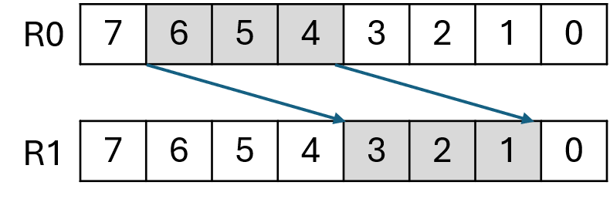

(b) (5 points) Assume an 8-bit system. Copy bits 6..3 in R0 to bits 5..2 in R1, and keep R1[7:6] and R1[1:0] unchanged.
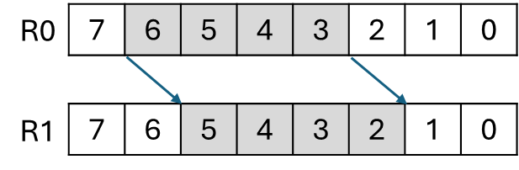

(c) (10 points) Assume a 32-bit system. R0 and R1 are initialized with the values below. Write a sequence of assembly instructions that would produce the values in registers R2–R5, from R0 and R1. Do not use MOVW + MOVT). Do not use pseudo-instructions LDR to load large constants into a register.
Given:
R0 | 0xCAFEBABE
R1 | 0x0000FFFF
Produce:
R2 | 0xCAFE4541
R3 | 0x0000CAFE
R4 | 0xBABEFFFF

Q5. (20 points) Program execution tracing
Assume a 32-bit system with big-endian memory addressing. The following assembly program operates on memory and registers. Fill in the values of registers R1 through R7 and the final memory contents after the entire program has finished executing. Write your answers in hexadecimal format. Assume initially NZCV = 0000.
Assembly program:
LDR R1, =0x20000000
LDR R2, [R1]
LDR R3, [R1, #4]!
LSR R4, R2, #12
MOVW R5, #7
LSL R6, R5, #8
BIC R7, R2, R6
STR R7, [R1, #8]
Initial memory contents:
Addr | Content
0x20000000 | AB | CD | EF | 01 | 23 | 45 | 67 | 89 | FE | DC | BA | 98 | 76 | 54 | 32 | 10

Final register values:
R1 | R2 | R3 | R4
R5 | R6 | R7

Final memory contents:
Addr | Content
0x20000000

Q6. (20 points) Assume a 32-bit system. Consider an array[] of 20 integers (each integer is 4 bytes). Assume register R0 holds the base memory address of array, i.e., array[0]. A compiler associates variables z and y with registers R1 and R2, respectively. Translate this C program into ARM assembly language based on the provided comments. Use R3 as a temporary register. (Note: Assume z is an unsigned integer. You may choose to use either pre-index, or pre-index with update, or post-index addressing.)
C program:
uint32_t z = array[3] - y;
array[^4] = z * 16;
array[^5] = z / 4;
array[^6] = z + 20;
array[^7] = z | 0x1F;
Assembly program:
____________________________; load array[3] into temporary register R3
____________________________; z = array[3] - y
____________________________; R3 = z * 16
____________________________; store into array[4]
____________________________; R3 = z / 4
____________________________; store into array[5]
____________________________; R3 = z + 20
____________________________; store into array[6]
____________________________; R3 = z | 0x1F
____________________________; store into array[7]

